Date: 11.07.2025
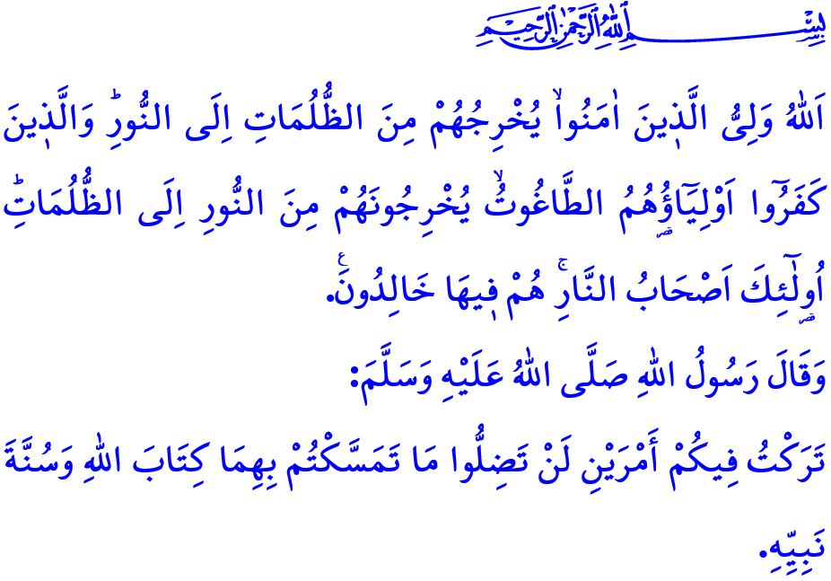
SIGNIFICANCE OF AUTHENTIC RELIGIOUS KNOWLEDGE
Honorable Muslims!
Next Tuesday marks the anniversary of the treacherous coup attempt in which FETO targeted our nation’s unity and the indivisible integrity of our homeland. It has been exactly nine years since our glorious resistance, in which, by Allah the Almighty’s grace, our state’s determination, and the courage of our noble nation, we overcame the treacherous plots of the traitors. That night, in the face of both internal and external forces of evil intent on seizing our independence and future, we stood united, women and men, young and old, hand in hand, shoulder to shoulder. Amid the solemn salats rising from the minarets, and with a spirit of unity, solidarity, and shared resolve, we thwarted the vile ambitions of those who dared cast an eye upon our homeland. With the manifestation of the verse, يَٓا اَيُّهَا الَّذ۪ينَ اٰمَنُٓوا اِنْ تَنْصُرُوا اللّٰهَ يَنْصُرْكُمْ وَيُثَبِّتْ اَقْدَامَكُمْ “O believers! If you stand up for Allah, He will help you and make your steps firm.”, that night, when, by Allah’s grace, we allowed neither traitors nor separatists to prevail, and inscribed a glorious epic into our nation’s history, alhamdulillah.
Dear Believers!
Our sublime religion, Islam, is a religion of peace and salvation that grants honor and dignity to human beings, and instills trust and righteousness. Yet despite this, throughout history certain individuals and groups have not refrained from exploiting Islam and its sacred values for their own selfish ends. In pursuit of their treacherous schemes, they have not hesitated to exploit people’s purest and most sincere sentiment, their religious faith. They have gone so far as to use the name of Allah, the Holy Qur’an, our beloved Prophet (saw), and even acts of worship as mere instruments to achieve their own ends.
Yet it must be known: so long as there are hearts filled with love for Allah and His Messenger, and minds illuminated by sound and authentic knowledge of the religion, no manipulator has ever achieved their dark ambitions, nor shall they ever succeed. As long as generations loyal to their homeland, nation, faith, and state continue to rise, no traitor who surrenders their mind, heart, and soul to the devil has ever brought our nation to its knees—and by Allah’s will, never shall. For indeed, in the verse of the Noble Qur’an with which I began my khutbah, our Exalted Lord gives us the glad tidings that He will never leave His believing servants alone or without support. “Allah is the Guardian of the believers —He brings them out of darkness and into light. As for the disbelievers, their guardians are false gods who lead them out of light and into darkness. It is they who will be the residents of the Fire. They will be there forever.”
Esteemed Muslims!
The betrayal of July 15 has shown us that authentic religious knowledge, grounded firmly in the Qur’an and Sunnah, is indispensable. In the hadith I recited at the start of my khutbah, our beloved Prophet (saw) warns us thus: “I have left you two things; as long as you hold fast to them, you will never go astray. They are: Allah’s Book and the Sunnah of His Prophet.”
Authentic religious knowledge is the most reliable refuge and the strongest shield in living out our faith, preserving it, and passing it on to future generations. In a society where authentic religious knowledge prevails, innovations and superstitions find no place to take root, exploitation and manipulators are barred entry, and the flames of discord and corruption cannot be ignited. One cannot deny the profound bond between faith, homeland, and national identity. No person or ideology can be placed above Allah and His Messenger.
Dear Believers!
Even today, those who seek to undermine our nation’s unity and brotherhood, and who threaten the future of the Ummah of Muhammad, have not abandoned their insidious ambitions. It is incumbent upon us to heed the warning of our Prophet (saw), لَا يُلْدَغُ الْمُؤْمِنُ مِنْ جُحْرٍ وَاحِدٍ مَرَّتَيْنِ “The believer should not be stung from the same hole twice.”, and remain vigilant and not let down our guard. It is our duty to be conscious, prudent, and discerning against those who seek to exploit our family structures, acts of worship, and sacred values. What falls upon us is to take personal responsibility for our children and youth entrusted to us by Allah, ensuring they are not left at the mercy of abusers and misguided ideologies. We are responsible to ensure that they receive authentic religious knowledge through correct methods and approaches, drawn from sound sources, and taught by competent and trustworthy individuals.
On this occasion, I would like to commemorate with mercy our honored martyrs who have sacrificed their lives for religion, homeland, and sacred values from past to present, as well as the sons of our nation who drank the cup of martyrdom this week in the Operation Claw-Lock zone, and I would also like to remember with gratitude and deep respect our heroic veterans.

I would like to conclude this Friday’s khutbah with the following hadith of the Messenger of Allah (saw): “How wretched is the person who uses religion for worldly gain! How wretched is the person whom desires and wishes lead astray!”

Muhammad, 47/7.
Baqarah, 2/257.
Muwatta’, Qadar, 3.
Bukhari, Adab, 83.
Tirmidhi, Sifat al-Qiyamah, 17. General Directorate of Religious Services

